**Power Electronics and Drive Assignment-2**

**ANTU ROY (M230635EE)**

Design a speed-controlled Dc motor drive maintaining the field flux constant. The motor parameters and rating are as follows; 220V, 8.3A, 1470rpm, Ra =4Ω, J=0.0607kg/m2, La = 0.072H, Bt = 0.0869N − m/rad/sec. Kb=1.26V /rad/sec. The converter is supplied from 230v, 3-phase AC at 60Hz.The converter is linear, and its maximum control input voltage is ±10V. The tacho generator has the transfer fucntion Gω(s) = 0.065/1+0.002s the speed reference has a voltage maximum of 10V. the maximum current permitted in the motor is 20A.

**Speed Vs Time Response of the Speed Transfer Functions with and Without Compensated Model**

**Uncompensated Model**

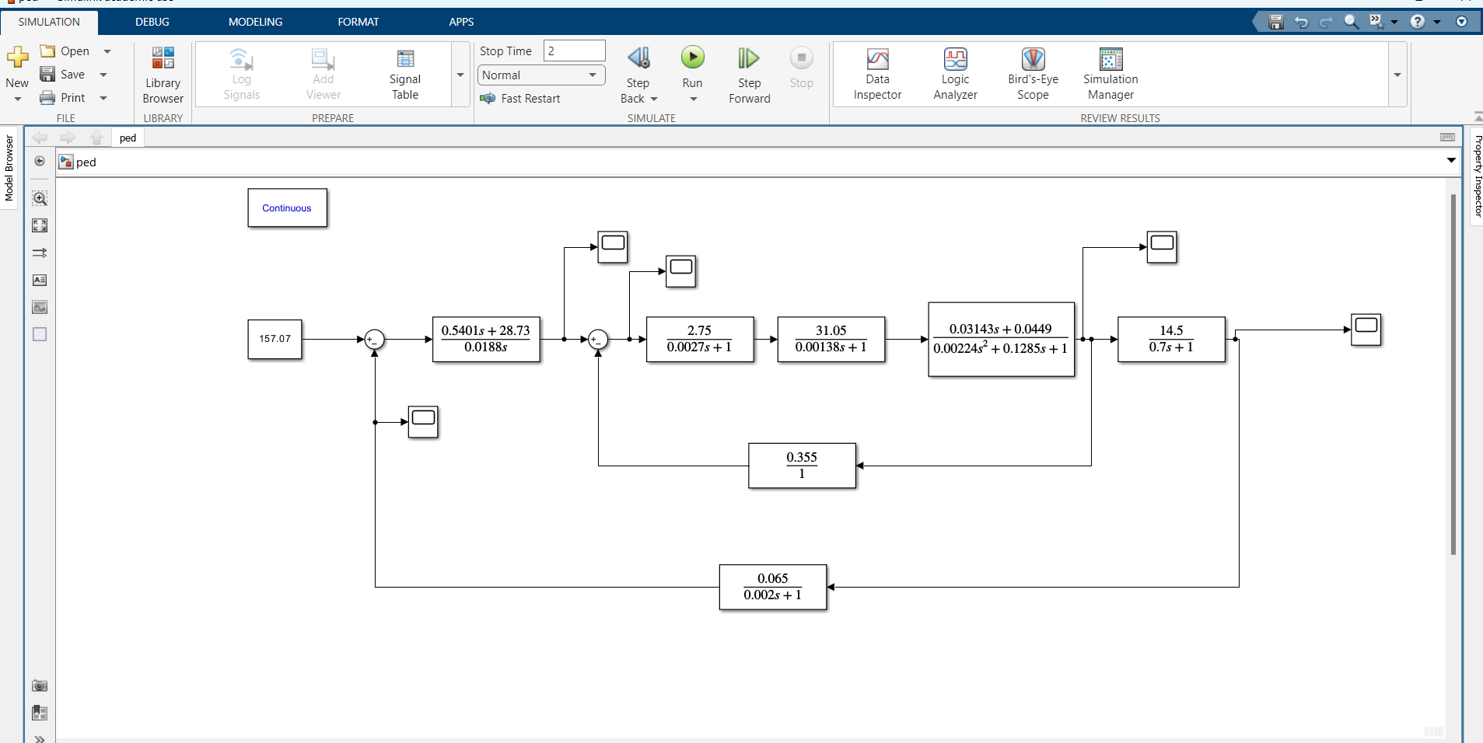

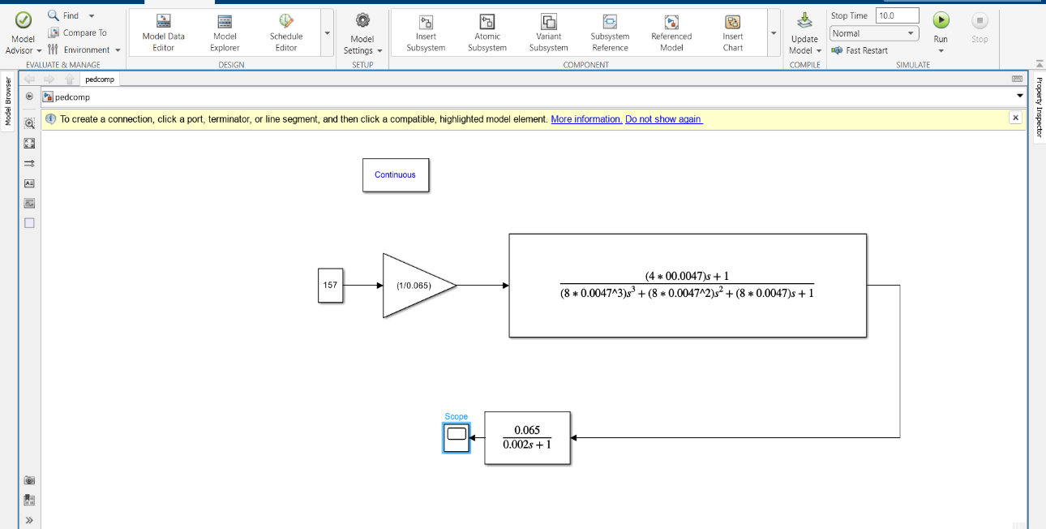

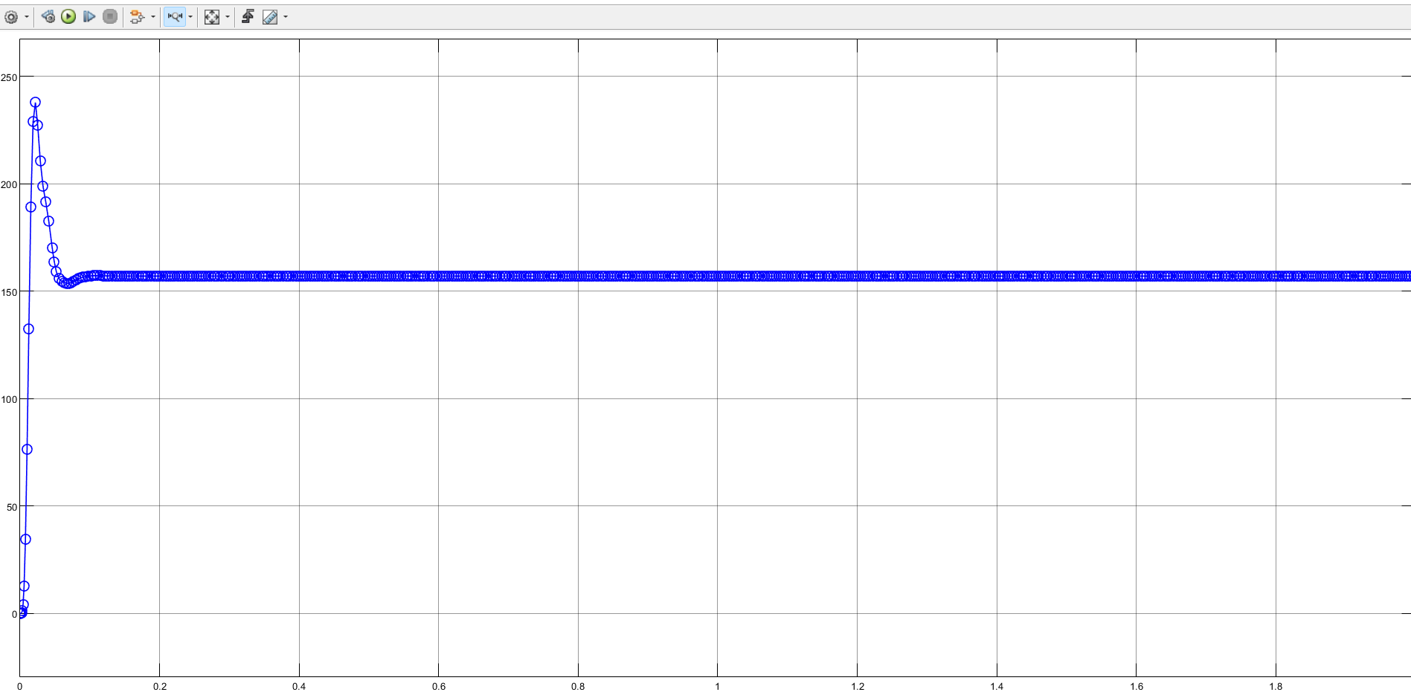

**Compensated Model**

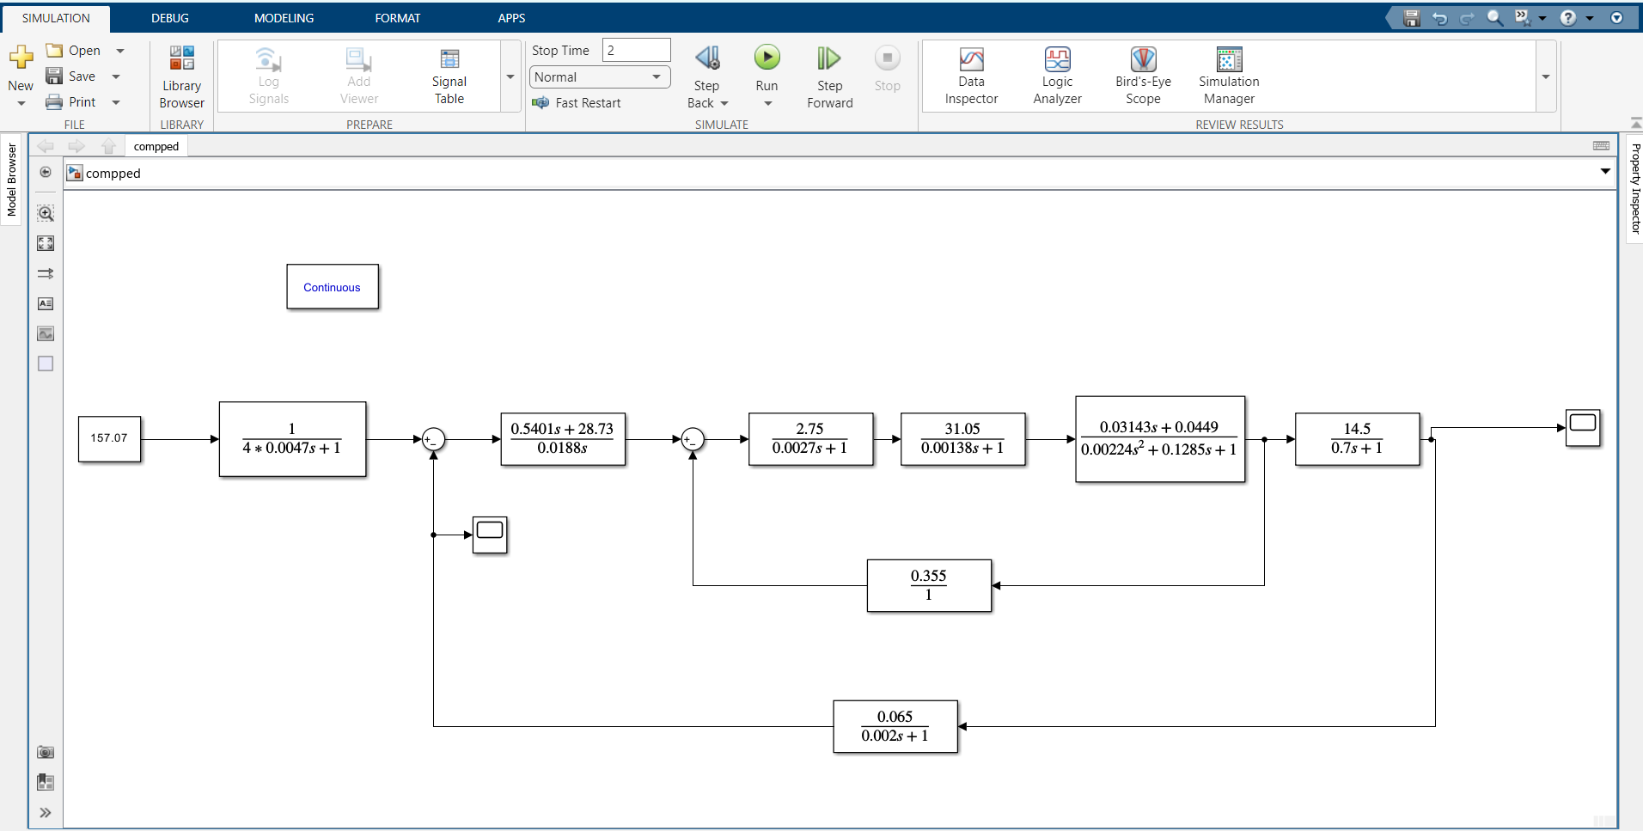

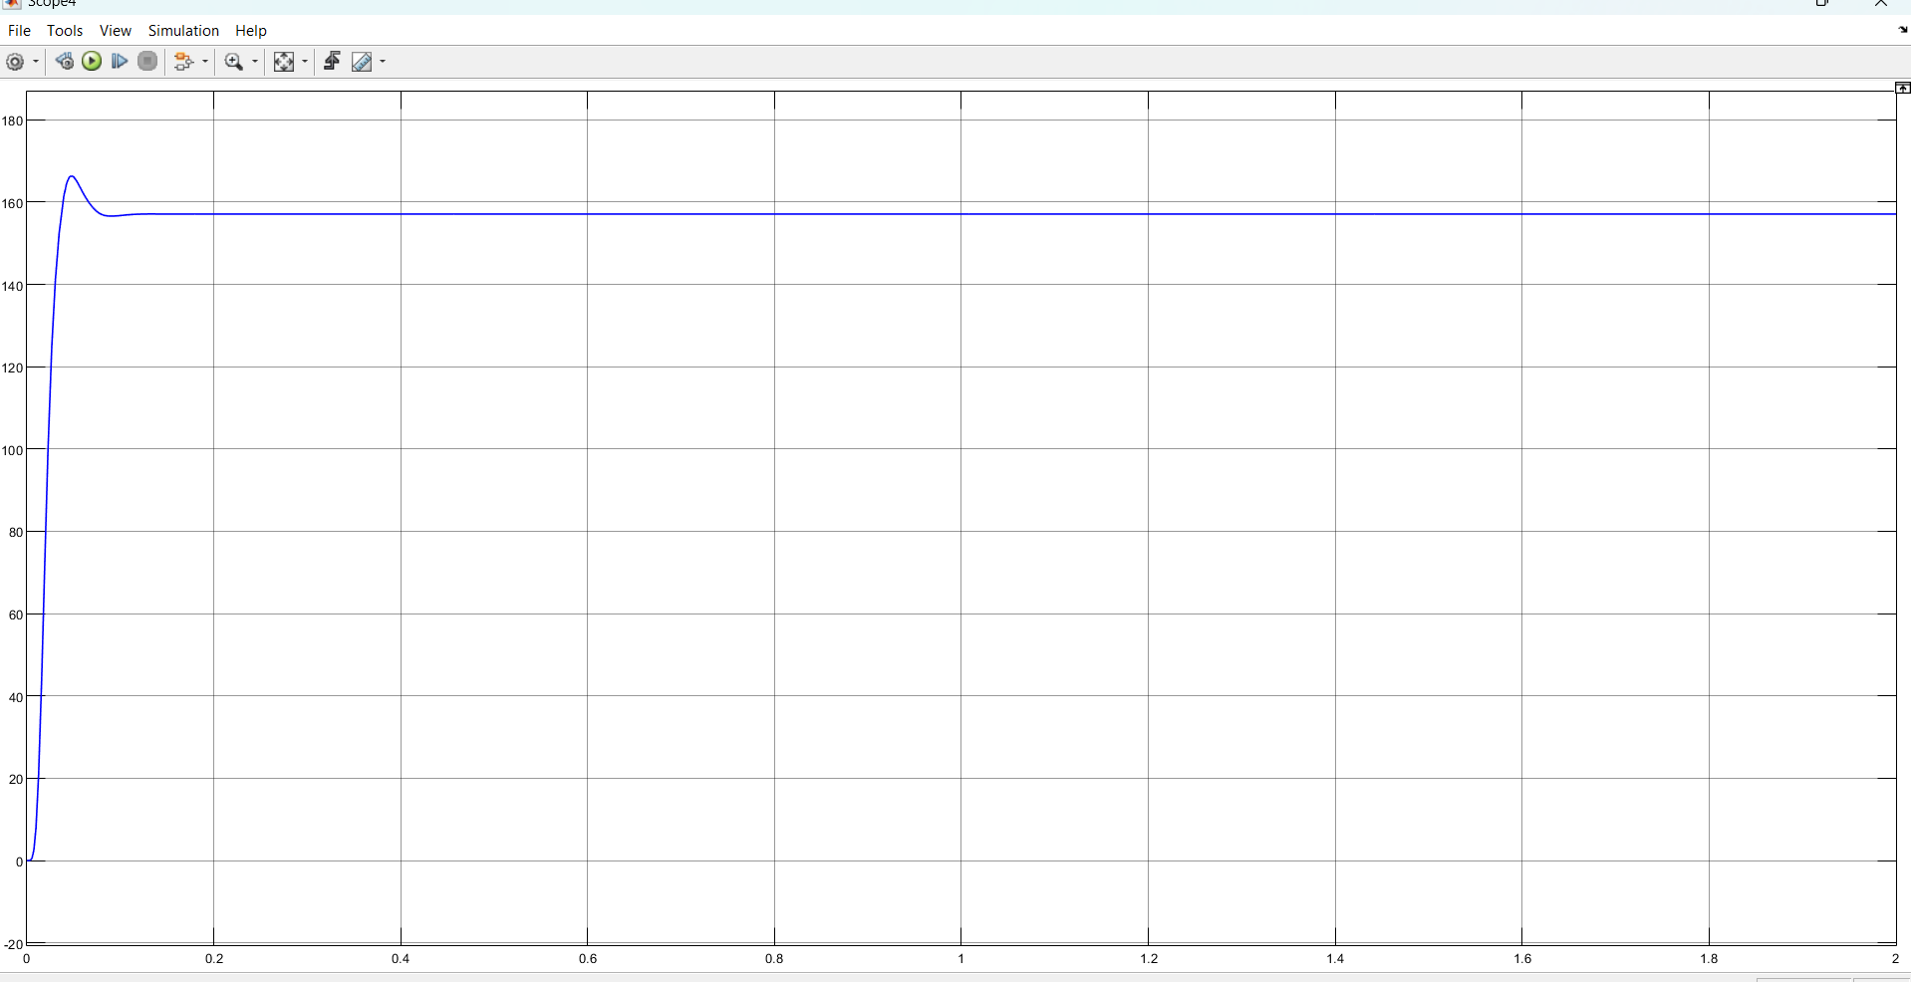

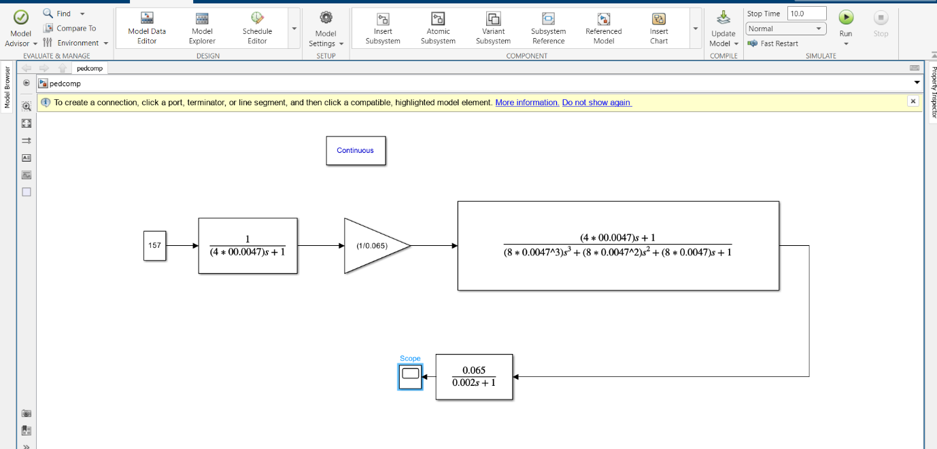

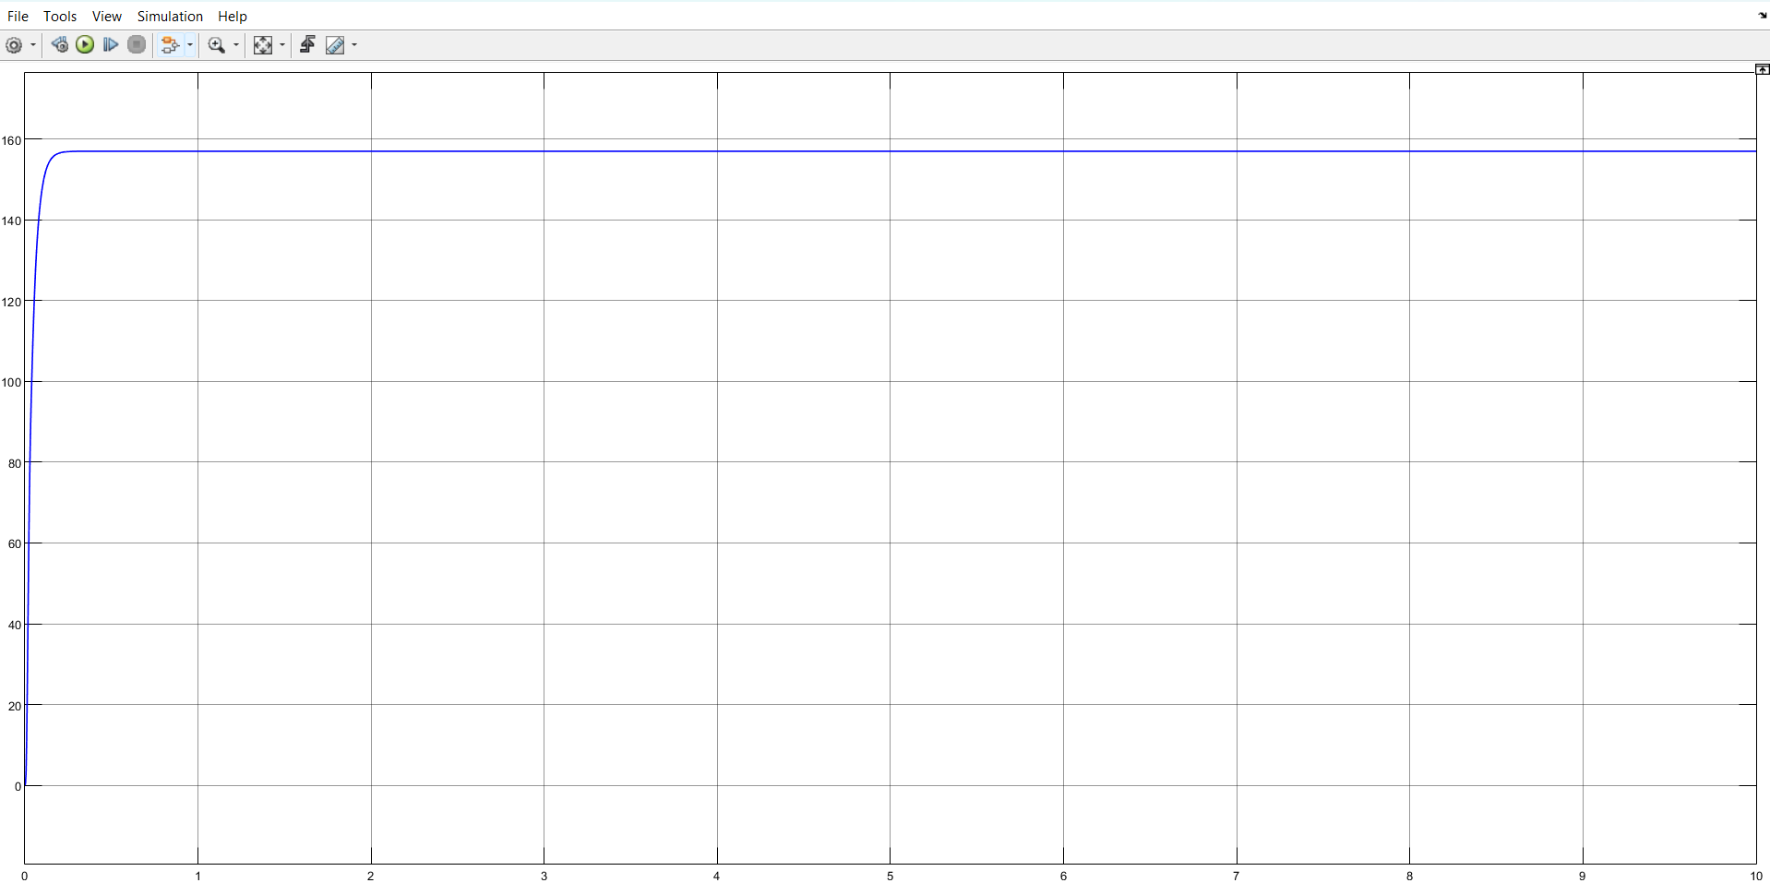

**Frequency Response of the Speed Transfer Functions with and Without Compensated Model**

% Numerator

num = [0.2892 15.38];

% Denominator

den = [(8*0.0047^3) (8*0.0047^2) (8*0.0047) 1];

% Transfer Function

G1 = tf(num, den)

% Plot Frequency Response

bode(G1), grid

% Numerator

num = [(1/0.065)];

% Denominator

den = [(8*0.0047^3) (8*0.0047^2) (8*0.0047) 1];

% Transfer Function

G2= tf(num, den)

% Plot Frequency Response

bode(G2), grid

bode(G1,G2)

